Project Design Phase
Problem – Solution Fit Template

Date | 09 September 2026
Team ID | SWUID2026190415
Project Name | Medical Diagnosis Center by Service Portal (ServiceNow)
Maximum Marks | 2 Marks

Problem – Solution Fit Template:
The Problem–Solution Fit helps us understand the real problems faced by patients and diagnostic center staff and identify a solution that fits their needs. The Medical Diagnosis Center by Service Portal (ServiceNow) is designed to reduce manual work, improve appointment management, provide digital reports, and automate healthcare services.
Purpose:
- Solve appointment booking and report management problems using ServiceNow.
- Provide a simple digital platform for patients and diagnostic center staff.
- Reduce waiting time and manual paperwork.
- Improve communication through automated notifications.
- Provide secure access to reports, appointments, and payments.
Template: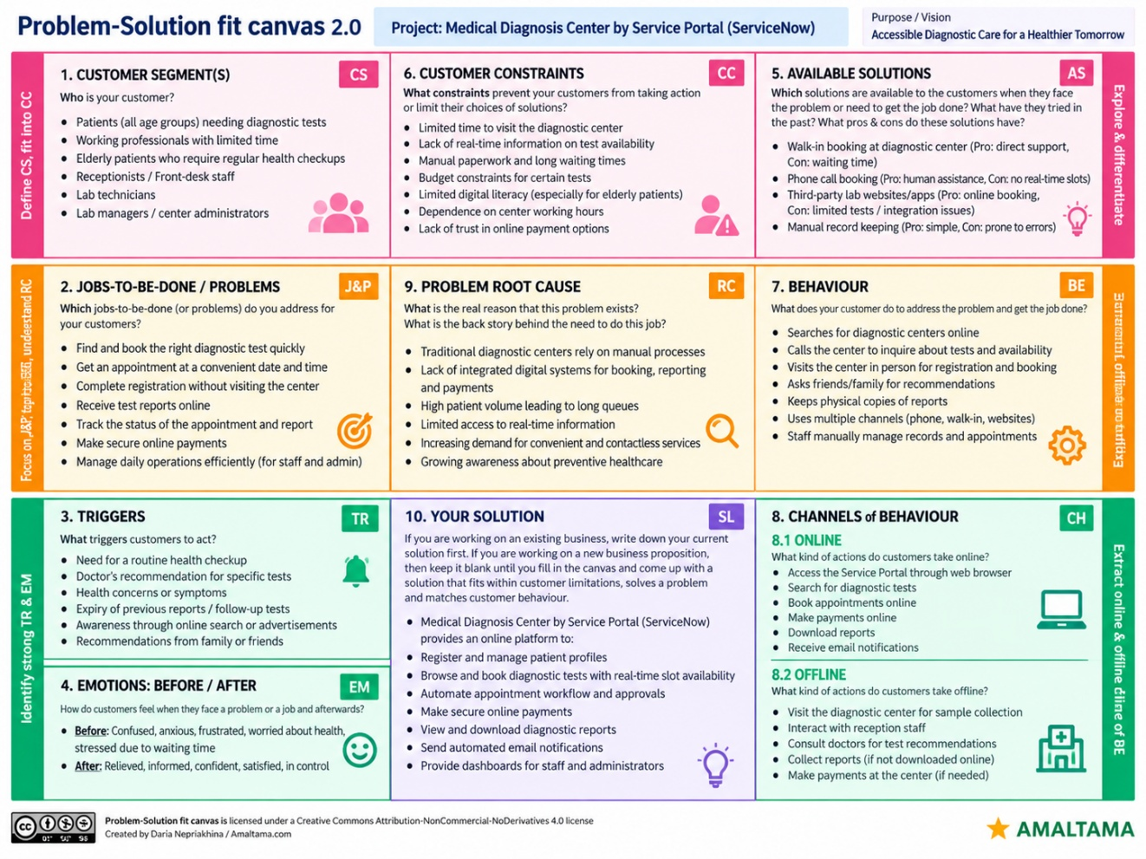

References:
- https://www.ideahackers.network/problem-solution-fit-canvas/
- https://medium.com/@epicantus/problem-solution-fit-canvas-aa3dd59cb4fe

